Use PISCESICC.py and PISCESCL.py and the following card to check it manually

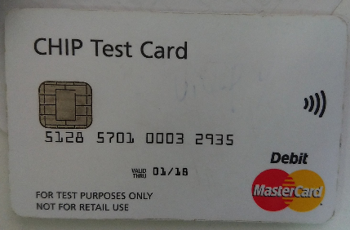

(Contact Interface from this card could get:)

PAN(5A)

Track 2 Equivalent Data(57)

Track 2 Discretionary Data(9F20)

Encipherd Online PIN(99)

(Contactless Interface from this card could get:)

M/Chip Track 2 Data(DFEF18)

---

Track 1 Equivalent Data(56) and M/Chip Track 1 Data(DFEF17) need other test cards.